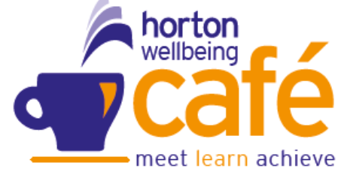
Wellbeing Café
May 2026


SELBY St Richards Centre, 36 Barwic Parade, Selby, 10am-12noon (weekly)
EGGBOROUGH Methodist Church Wednesday 10am – 12pm (Weekly)
SHERBURN Harold Mills House, Thursday 1pm – 3pm (Weekly)
TADCASTER Calcaria House, Windmill Rise Tuesday 10 – 12noon (Weekly)
 Hot Women – Menopause run by Jackie Butterworth @ Community House Selby –10am to 12pm
 Laura Simpson NY Fire Service @ Eggborough Methodist Church, Selby Rd

Sunday | Monday | Tuesday | Wednesday | Thursday | Friday | Saturday
3 | 4 | 5  Tadcaster  Coffee, Talk, Mindful Activities | 6  Eggborough  Coffee, Talk & Mindful Activities | 7  Selby  Sherburn  Coffee,, Talk & Mindful Activities | 8 | 9
10 | 11 | 12  Tadcaster  Coffee, Talk, Mindful Activities | 13  Eggborough  NY Fire service  Coffee, Talk & Mindful Activities | 14  Selby  Sherburn  Coffee, Talk & Mindful Activities | 15 | 16
17 | 18 | 19  Tadcaster  Coffee, Talk, Mindful Activities | 20  Eggborough  Coffee, Talk & Mindful Activities | 21  Selby  Sherburn  Coffee, Talk & Mindful Activities | 22 | 23    10am to 12pm  @ Community House
24 | 25 | 26  Tadcaster  Coffee, Talk, Mindful Activities | 27  Eggborough  Coffee, Talk & Mindful Activities | 28  Selby  Sherburn  Coffee, Talk & Mindful Activities | 29 | 30
31

