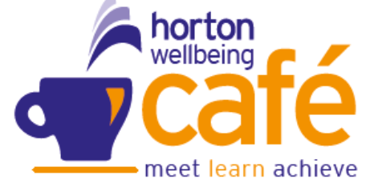
Wellbeing Café
April 2026



SELBY St Richards Centre, 36 Barwic Parade, Selby, 10am-12noon (weekly)
EGGBOROUGH Methodist Church Wednesday 10am – 12pm (weekly)
SHERBURN Harold Mills House, Thursday 1pm – 3pm (Weekly)
TADCASTER Calcaria House, Windmill Rise Tuesday 10 – 12noon (Weekly)
 Hot Women – Menopause run by Jackie Butterworth @ Community House Selby –10am to 12pm
 Laura Simpson NY Fire Service @ Calcaria House, Windmill Rise, Eggborough

Sunday | Monday | Tuesday | Wednesday | Thursday | Friday | Saturday
 |  |  | 1  Eggborough  Coffee, Talk & Mindful Activities | 2  Selby  Sherburn  Coffee, Talk & Mindful Activities | 3 | 4
5 | 6 | 7  Tadcaster  Coffee, Talk, Mindful Activities | 8  Eggborough  Coffee, Talk & Mindful Activities | 9  Selby  Sherburn  Coffee, Talk & Mindful Activities | 10 | 11
12 | 13 | 14  Tadcaster  Coffee, Talk, Mindful Activities | 15  Eggborough  NY Fire service  Coffee, Talk & Mindful Activities | 16  Selby  Sherburn  Coffee, Talk & Mindful Activities | 17 | 18
19 | 20 | 21  Tadcaster  Coffee, Talk, Mindful Activities | 22  Eggborough  Coffee, Talk & Mindful Activities | 23  Selby  Sherburn  Coffee, Talk & Mindful Activities | 24 | 25    10am to 12pm  @ Community House
26 | 27 | 28  Tadcaster  Coffee, Talk, Mindful Activities | 29  Eggborough  Coffee, Talk & Mindful Activities | 30  Selby  Closed  Sherburn  Coffee, Talk & Mindful Activities

Selby Café will be closed on the 30th.

