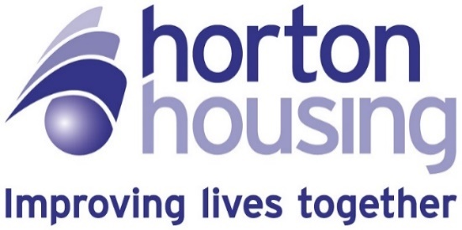

Statement of Purpose
Horton Housing Association,
Chartford House,
54 Little Horton Lane,
Bradford,
BD5 0BS

Ofsted Registration 2764615

Nominated Individual
Gudrun Haskins-Carlisle

Registered Service Manager
Esther Douglas

Contents

Introduction 4
Statement of Purpose: Section 1 4
1. Our Purpose, Ethos and Core Aims 4
2. Category of Supported Accommodation offered 5
3. Our Facilities 6
Whitehall Road Overview 7
Internal Configuration 7
External Facilities and Location 8
Outdoor Areas 8
Additional Amenities 8
Local Accessibility 9
Park House Overview 9
Outdoor Facilities and Location 10
Wren House Specialist Group Living Service 10
Outdoor and Community Facilities 11
4. Accommodation Standards 12
General Standards 12
Servicing, Safety, and Maintenance 12
Maintenance and Repairs 13
Insurance and Safety Measures 13
5. The Address of the Registered Provider 13
6. Our Organisational Structure 14
Staff Training, Development, and Support 14
Learning and Development 14
Recruitment and Induction 15
Probation and Supervision 15
Progress, Performance and Development 15
Team Meetings 15
Qualifications 15
7. Children’s Rights, Service Delivery, Support, and Planning 16
8. Entitlements of Young People in Our Service 17
Legal Rights and Supporting Legislation 17
Categories of Support 17
Entitlements for Eligible Children 17
Support for Other Categories 18
Pathway Plan 18
Reviews 18
Visits …….. 18
Financial Support 18
Personal Adviser for Care Leavers 19
Homeless Young People 19
Support for Unaccompanied Asylum-Seeking Children (UASC) 19
Advocacy and Involvement in Decision-Making 19
9. Achieving Positive Outcomes 20
Health and Wellbeing 20
Education 20
Staying Safe 20
Budgeting and Personal Finances 21
Maintaining a Home 21
Cooking Skills 21
Independent Tenancy Options and Tenancy Readiness 21
Monitoring Progress 21
10. Education, training or employment support 21
11. Protecting and Supporting Mental and Physical Well-being 23
Anti-Discriminatory Practices 23
Meeting Individual Cultural, Linguistic and Religious Needs 23
12. How to complain and access our complaints policy 24
13. Child Protection Policies 25
Safeguarding Culture and Staff Responsibilities 25
Skills for Safeguarding 25
Support Planning and Assessment 25
Assessment, Training, and Policy Overview 25
Whistle-Blowing and Reporting Procedures 25
Building Relationships and External Links 26
Information and Advocacy 26
Information Sharing and Legal Compliance 26
Promoting Positive Relationships and Risk Awareness 26
Supervision and Safeguarding Practice 27
Understanding and Reporting Abuse 27
14. The Statement of Purpose: Section 2 27
15. The Statement of Purpose: Section 3 28

Introduction
This Statement of Purpose has been written in line with The Supported Accommodation (England) Regulations 2023. It has been set out to follow Regulation 9 of the Quality Standards and describes the benefits that young people will gain when being placed with us. It outlines the support we provide and how we are structured to provide that support. It provides an overview of the facilities, services and practices that we follow to ensure we provide a service that effectively delivers to the young people that we support.

Statement of Purpose: Section 1


Our Purpose, Ethos and Core Aims
Our vision is to help every young person achieve the best possible quality of life. We believe that, with the right support and guidance, all young people can develop the motivation and skills needed for a fulfilling future.
We recognise that young people in the social care system may feel unheard or isolated. Our goal is to provide a supportive, empowering environment where each young person can access education, vocational training, and a wide range of employment opportunities.
We are committed to:
- Creating a safe, secure, and welcoming home environment.
- Ensuring every young person’s voice is heard, respected, and advocated for.
- Building trust and confidence through skilled, compassionate support.
- Providing comfortable, well-maintained accommodation that young people can be proud of.
- Offering high-quality, personalized support for health and wellbeing.
- Meeting immediate needs, such as access to benefits, food, clothing, healthcare, and education or employment.
- Connecting young people with additional specialist support as needed.
- Respecting and celebrating individual diversity, empowering young people to make their own choices.
- Developing tailored support plans to help each young person achieve their goals.
- Encouraging practical training and activities to prepare for independent living.

Category of Supported Accommodation offered
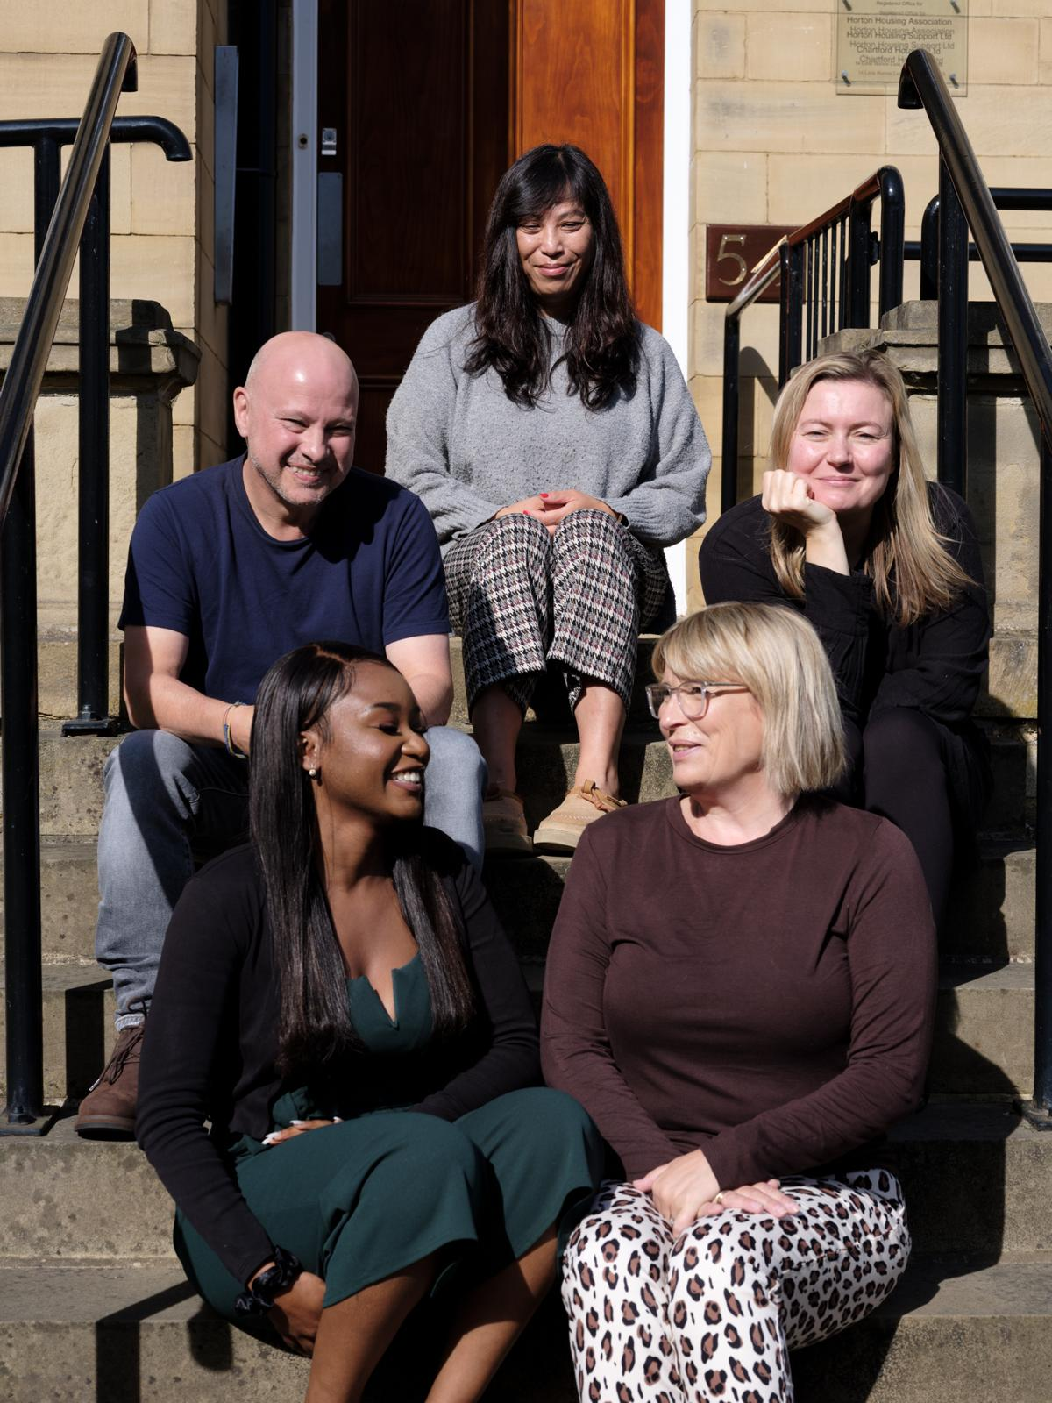
We provide shared and group accommodation, ringfenced specifically for looked-after children and care leavers. Our settings are designed to foster independence while offering the support and stability young people need as they transition to adulthood.
Our Services
We offer stable, consistent supported accommodation that ensures young people have continuous access to education, healthcare, and community resources. Our environment is designed to build self-esteem, reduce stigma, and help young people feel confident about their future.
While we do not provide personal care, we offer a nurturing and protective setting where young people can thrive and develop independence. Our trained staff are always present on-site and additional support is available as needed, including an emergency contact number provided in the young person’s guide.
Who We Support
Our accommodation is designed for young people who are ready to build their independence and do not require the level of care provided in children’s homes or foster care. We use a non-restraint policy and cannot accept placements where restraint is required.
We support young people with a range of needs, including:
- Unaccompanied asylum-seeking children (UASC).
- All genders and intersex young people.
- Those with emotional or behavioural difficulties.
- Neurodivergent young people.
- Young people not in education, employment, or training (NEET).
- Individuals at risk of or involved in crime, antisocial behaviour, or conduct disorder.
- Those needing support with independent living skills.
- Young people requiring supervision due to self-harming behaviours.
- Those with challenging behaviour, moderate learning disabilities, substance misuse, or gang involvement.


Our Facilities
Our accommodation consists of three homes designed to provide modern, secure, and comfortable living environments. Each room and communal area is equipped with Wi-Fi, and every young person has access to a TV both in their bedroom and in shared spaces, along with available computers.

Personal Space in the Home
Every resident is provided with a well-furnished, lockable bedroom that includes telephone and internet access. We supply standard bedding, towels, toiletries, and kitchen essentials. Each bedroom features lockable cabinets for valuables, allowing young people to safely store personal belongings. Residents are encouraged to bring in personal items and customise their rooms to suit their tastes.
The entire home, including individual rooms, is thoughtfully decorated and furnished to foster a warm and inviting atmosphere. We actively involve young people in decisions about décor and encourage them to share feedback or ideas at any time.
To ensure our properties stay suitable, we conduct an annual location assessment that considers input from stakeholders, especially the young people living with us. Health and safety are priorities, so premises are reviewed regularly. CCTV is strictly for the safety and welfare of residents, and we always respect privacy; use of CCTV is discussed with the responsible authority as per our framework agreement.
Each resident receives a written agreement and a young person’s guide in an accessible format, outlining their rights and the terms of supported accommodation. This also explains how to raise concerns.
We strive to make all our properties feel homely and welcoming, continuously seeking feedback from young people and considering short-term changes to help individuals feel more at ease in their space.
Young people can access all communal rooms and each person hold their own key for their bedroom. Staff may occasionally need to enter a resident's bedroom for welfare and health and safety checks, always providing advance notice unless there's an urgent risk to safety. In such cases, staff will explain the reason for entry directly to the young person involved.

Whitehall Road Overview
Whitehall Road accommodates eleven young people across three floors, offering each resident access to all areas of the property. Every individual is provided with a well-maintained bedroom, which includes a kitchenette and an en-suite bathroom, ensuring privacy and convenience. In addition to private spaces, residents can enjoy communal facilities such as a lounge and a kitchen, designed to promote a sense of community and shared living.

Internal Configuration
The internal layout at Whitehall Road is organised to maximise comfort and accessibility for all young people living within the home.

Ground Floor | First Floor | Second Floor
Entrance Hall  Staff Office  Managers Office  Staff/visitors toilet  Communal Kitchen  Communal Lounge/Dining Room  Laundry Room  Bedroom 1  External Move on Flat with own front door | Bedroom 3  Bedroom 4  Bedroom 5  Bedroom 6  Bedroom 7  Bedroom 8 | Bedroom 9  Bedroom 10  Bedroom 11
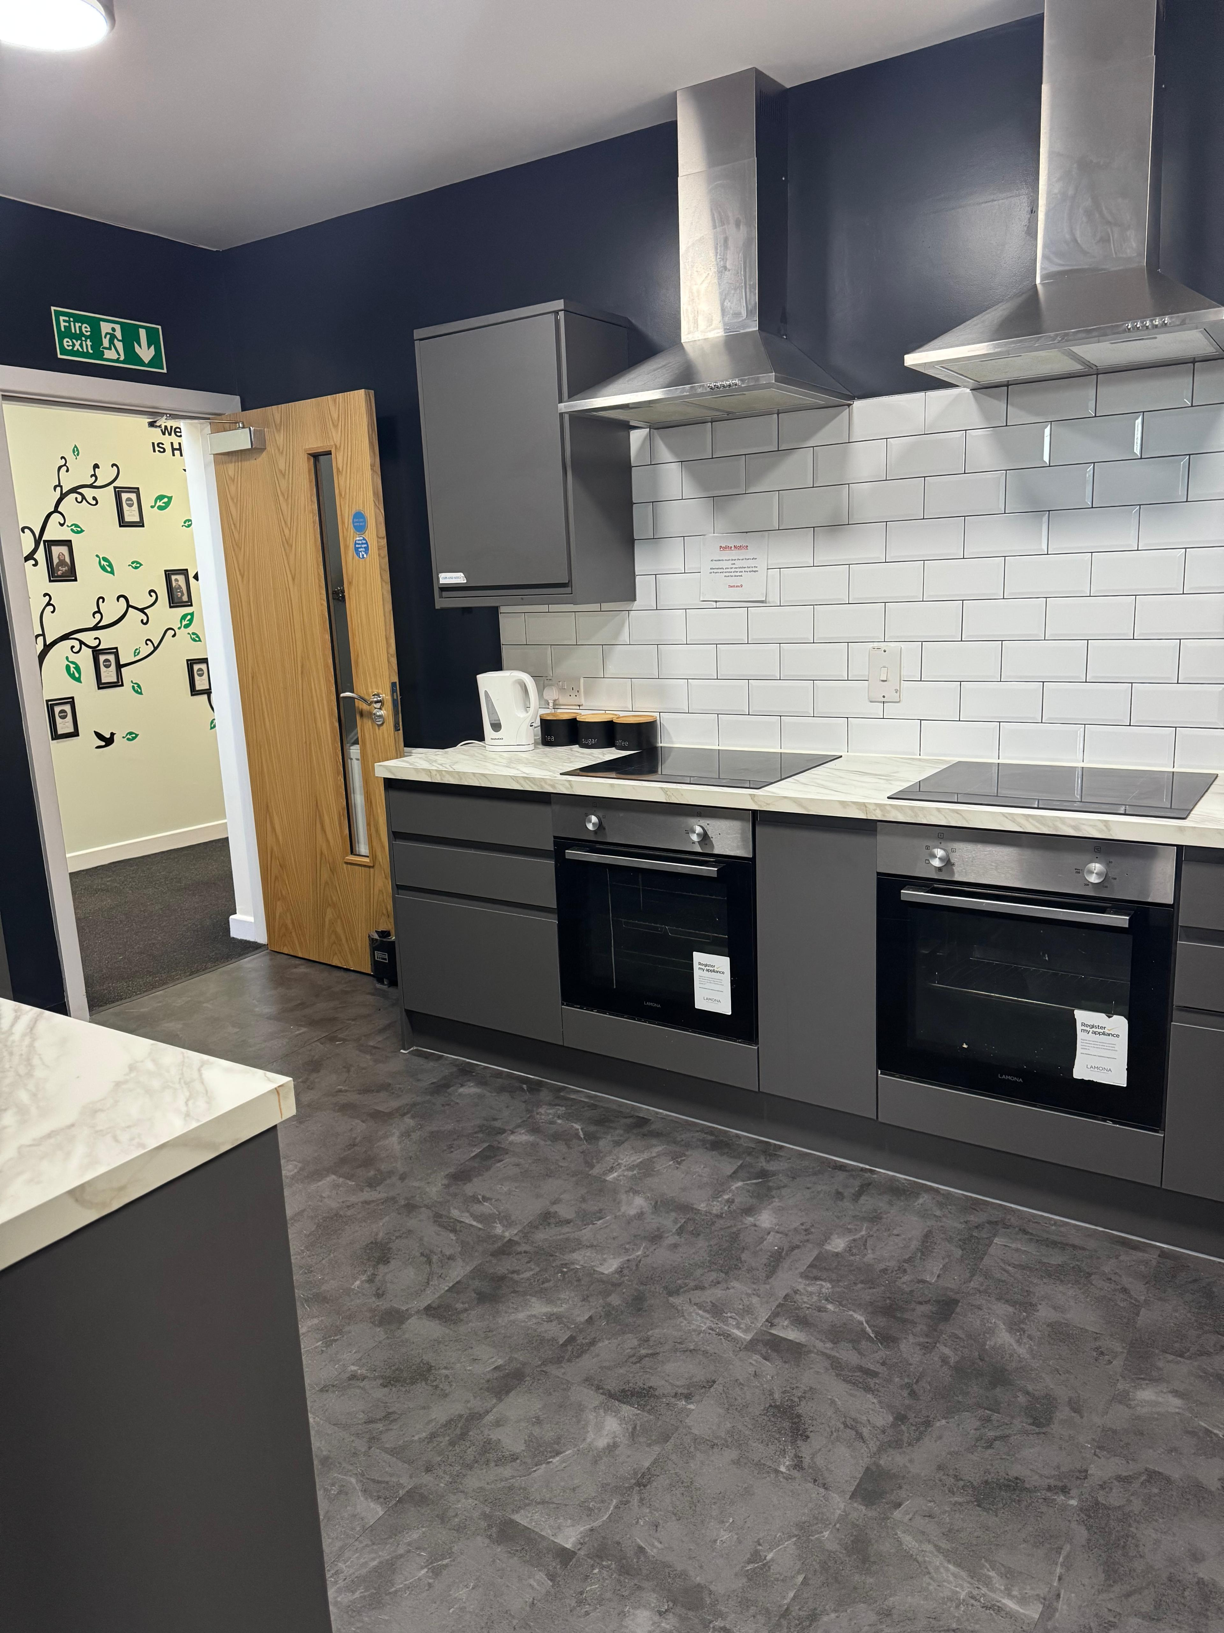
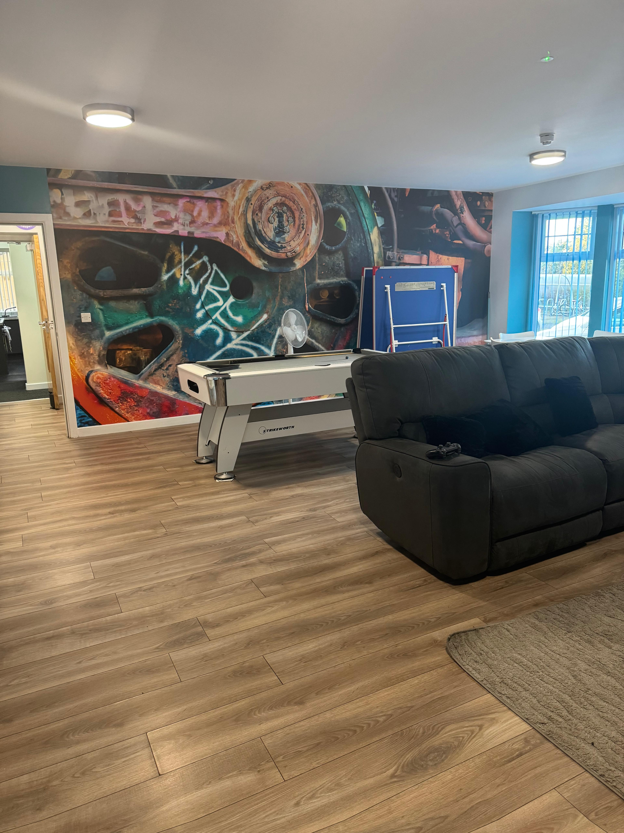
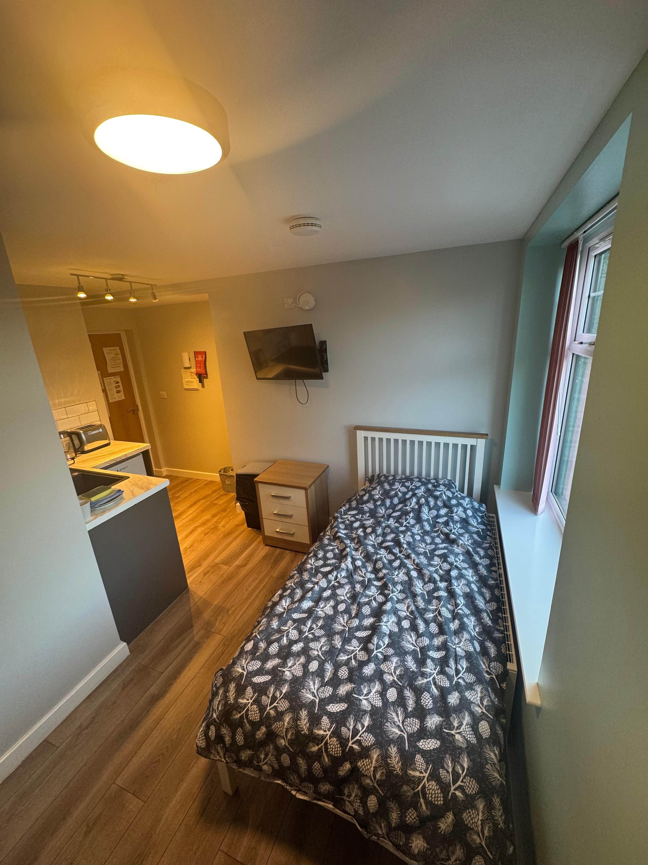

External Facilities and Location

Outdoor Areas
To the front of the house, there is a tarmac drive and an accessible area, providing convenient access for vehicles and visitors. At the rear of the property, residents can enjoy a grassed space designed for relaxation, which includes a dedicated chill-out area and seating for socialising or outdoor activities.

Additional Amenities
The property also benefits from a separate outbuilding used for storage, ensuring secure and organised space for belongings. In addition, there is a bike shed available, supporting active lifestyles and promoting cycling as a mode of transport.

Local Accessibility
Situated in Wyke, the location offers straightforward access to Huddersfield, Halifax, and Bradford. This ensures residents can easily reach public transport options, educational institutions, community resources, healthcare services, and other local amenities essential for daily living.
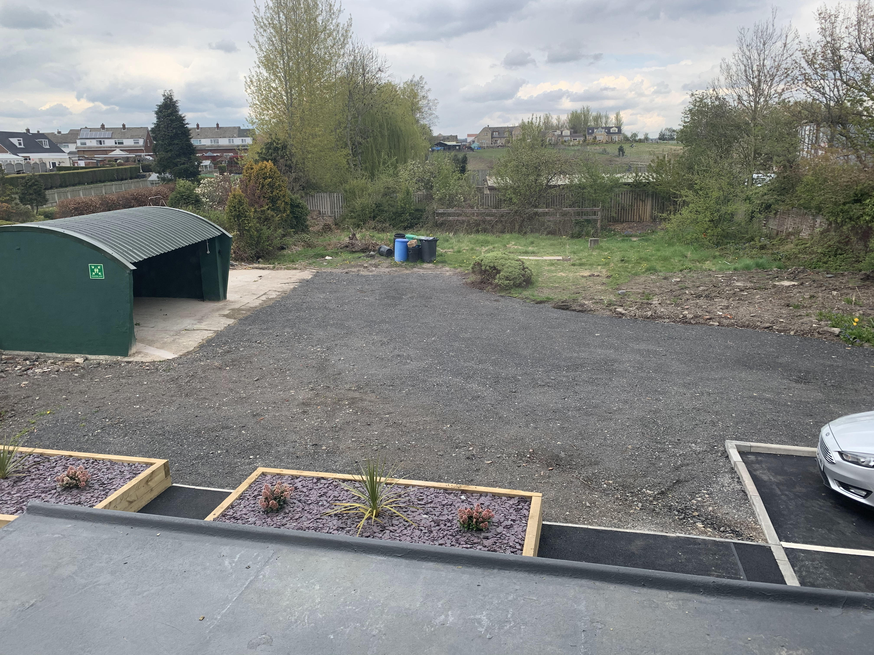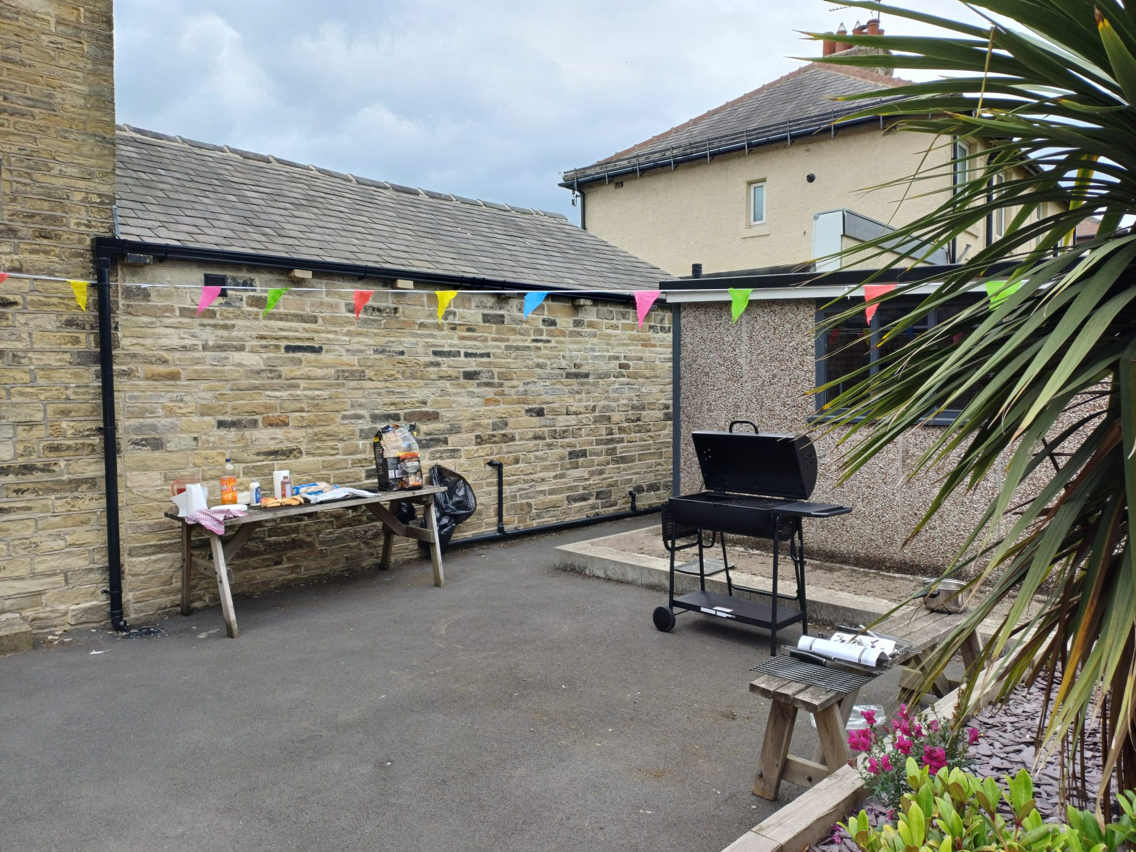

Park House Overview
Park House accommodates nine young people across three floors, offering a range of living arrangements designed to meet individual needs. The facility includes a self-contained move on flat, which features its own kitchen, bathroom, bedroom and living room, providing independent living space for one resident.
The remaining eight flats each include separate bedrooms and bathrooms, with a combined living room and kitchen area, fostering a supportive and communal atmosphere. Additionally, one of the flats is designed to accommodate siblings, as it includes two distinct bedrooms within the same unit.
Residents also benefit from a communal kitchen and activity room, alongside a shared living area that creates a homely environment for social interaction and group activities.
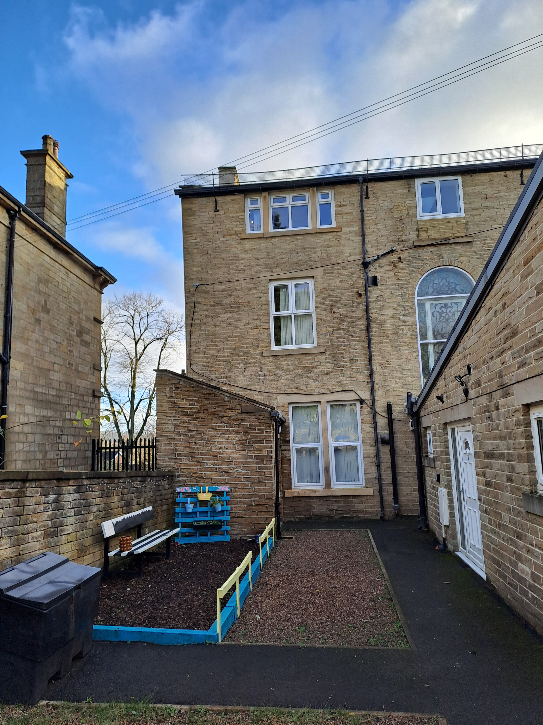
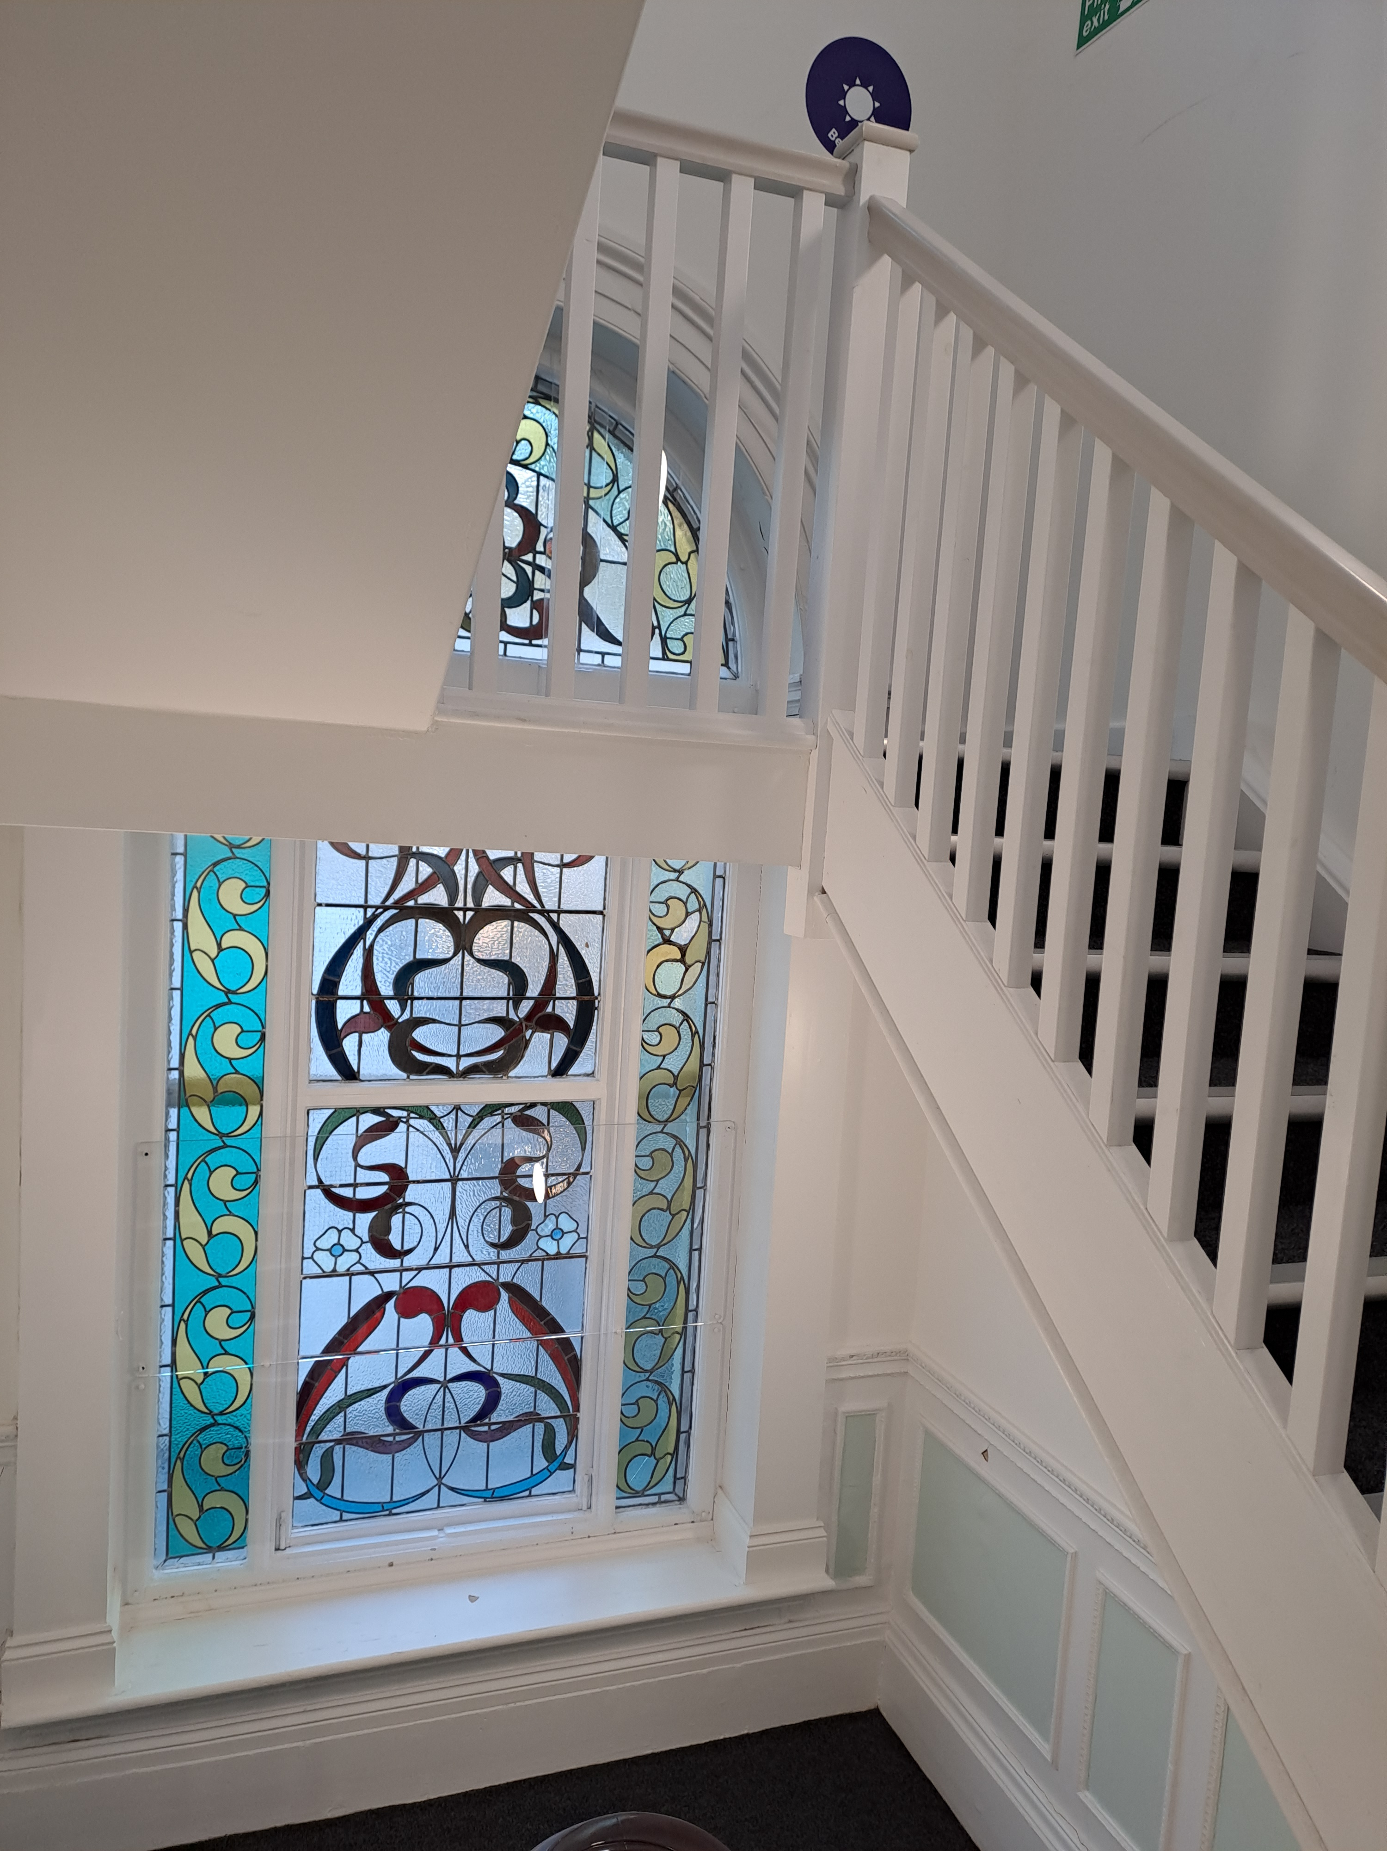
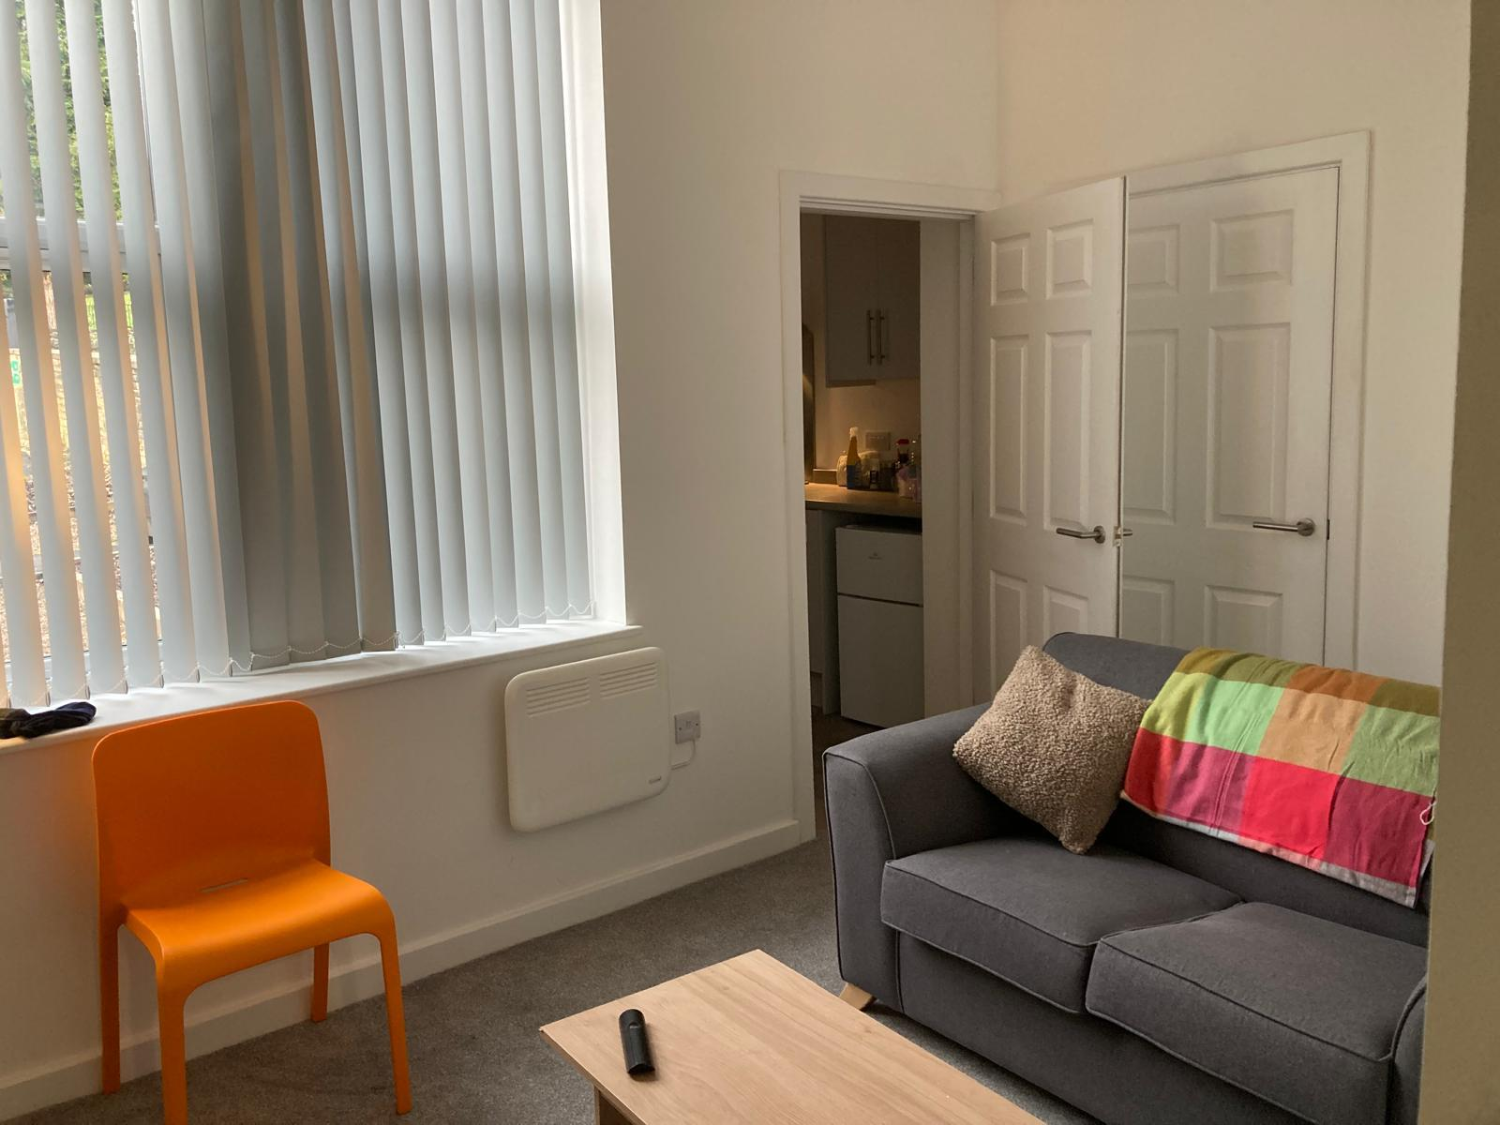
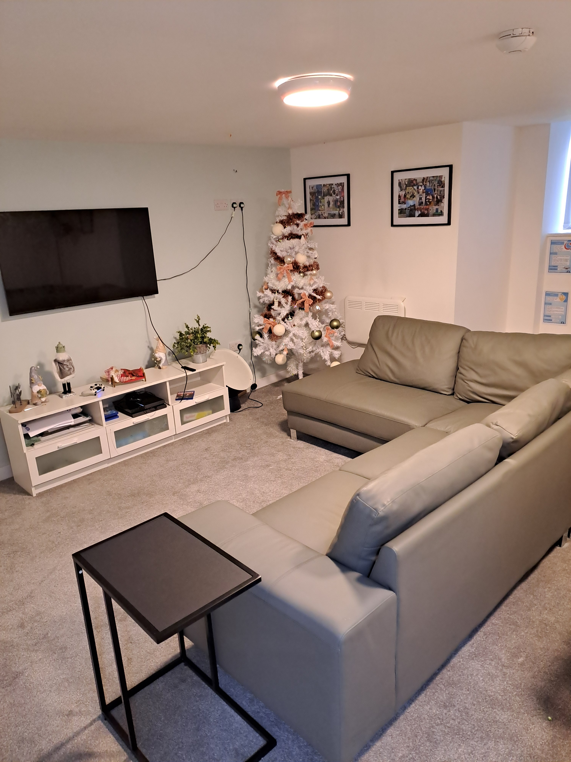
Ground Floor | Basement | First Floor | Second Floor
Entrance Hall  Staff/visitors toilet  Communal Kitchen/ activity and office space  Flat 1  Flat 2  Move on Flat 3  Flat 4 | Laundry Room  COSH Storage  Lounge/Dining Room | Flat 5  Flat 6  Flat 7 | Flat 8  Flat 9

Outdoor Facilities and Location
The property offers a variety of outdoor facilities designed to enhance residents’ quality of life. There are raised beds suitable for gardening, providing opportunities for outdoor activities and engagement with nature. An area designated for barbecues, along with outdoor seating, creates a welcoming space for social gatherings and relaxation. Additionally, the premises include a secure bike rack and ample parking for residents and visitors alike.
Situated next to Northcliffe Park, the home benefits from a highly central location. This prime positioning ensures convenient access to public transport, making it easy for residents to travel locally or further afield. The proximity to education and community facilities, as well as healthcare and other essential local services, supports the well-being and independence of those living at the property.

Wren House Specialist Group Living Service
Wren House provides specialist group living accommodation tailored for unaccompanied asylum-seeking children. The home offers capacity for 16 residents, ensuring a supportive and comfortable environment.
Two of these flats are situated on the first floor, while the remaining 14 are conveniently found on a single level. This arrangement allows for easy access and navigation throughout the facility.
Each resident benefits from a well-maintained bedroom that includes a kitchen area and an en-suite bathroom, providing personal space and privacy. In addition, Wren House features a communal lounge, equipped with a pool table, which serves as a central hub for social interaction and recreation among residents.
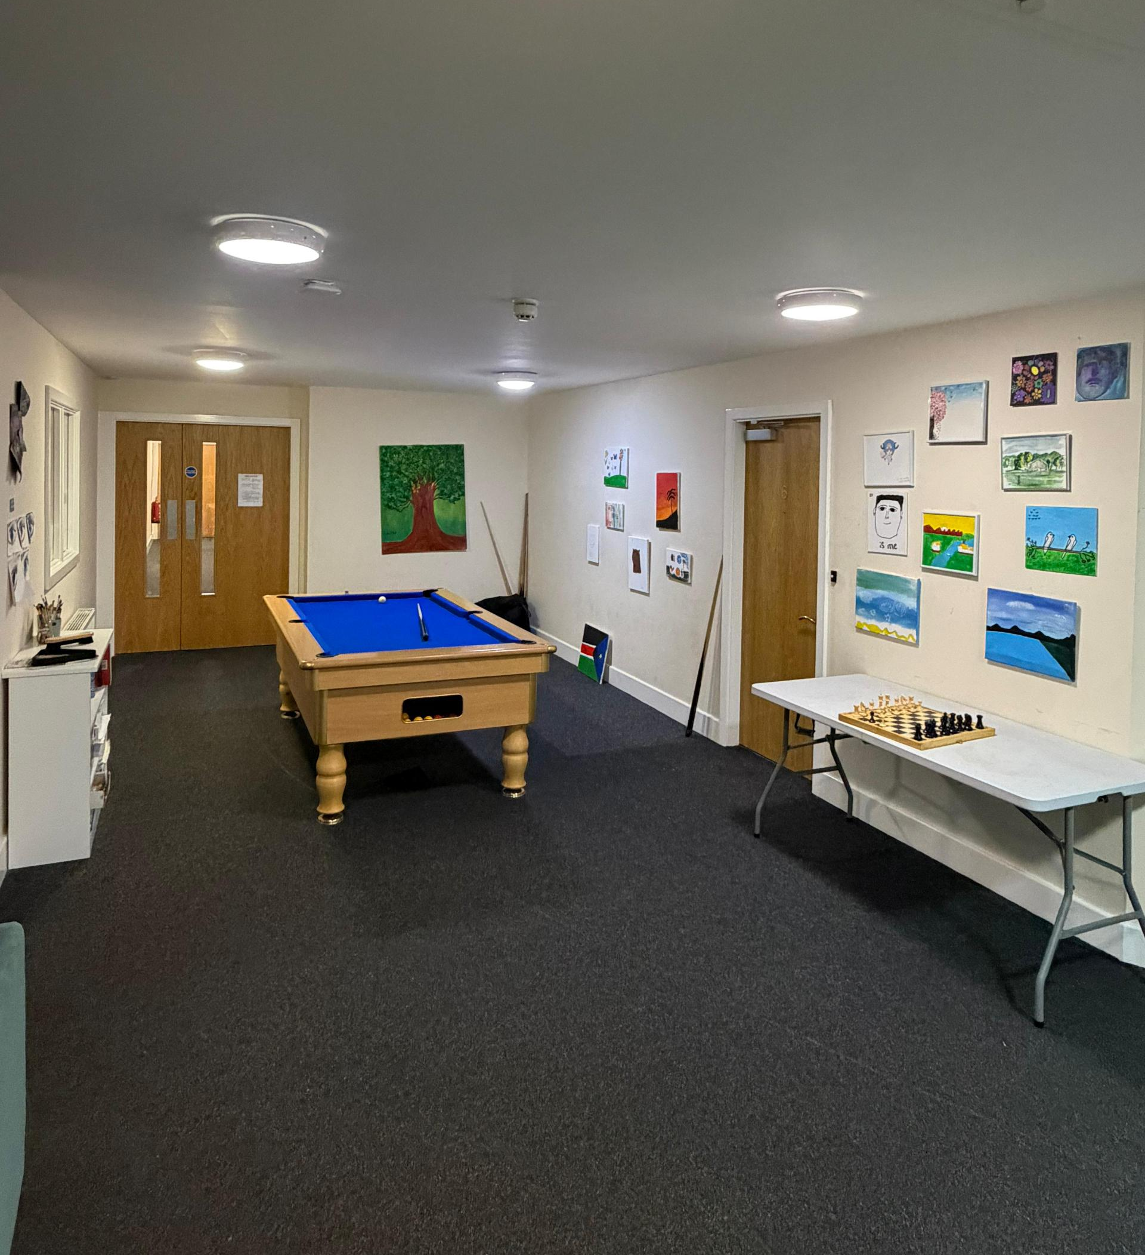
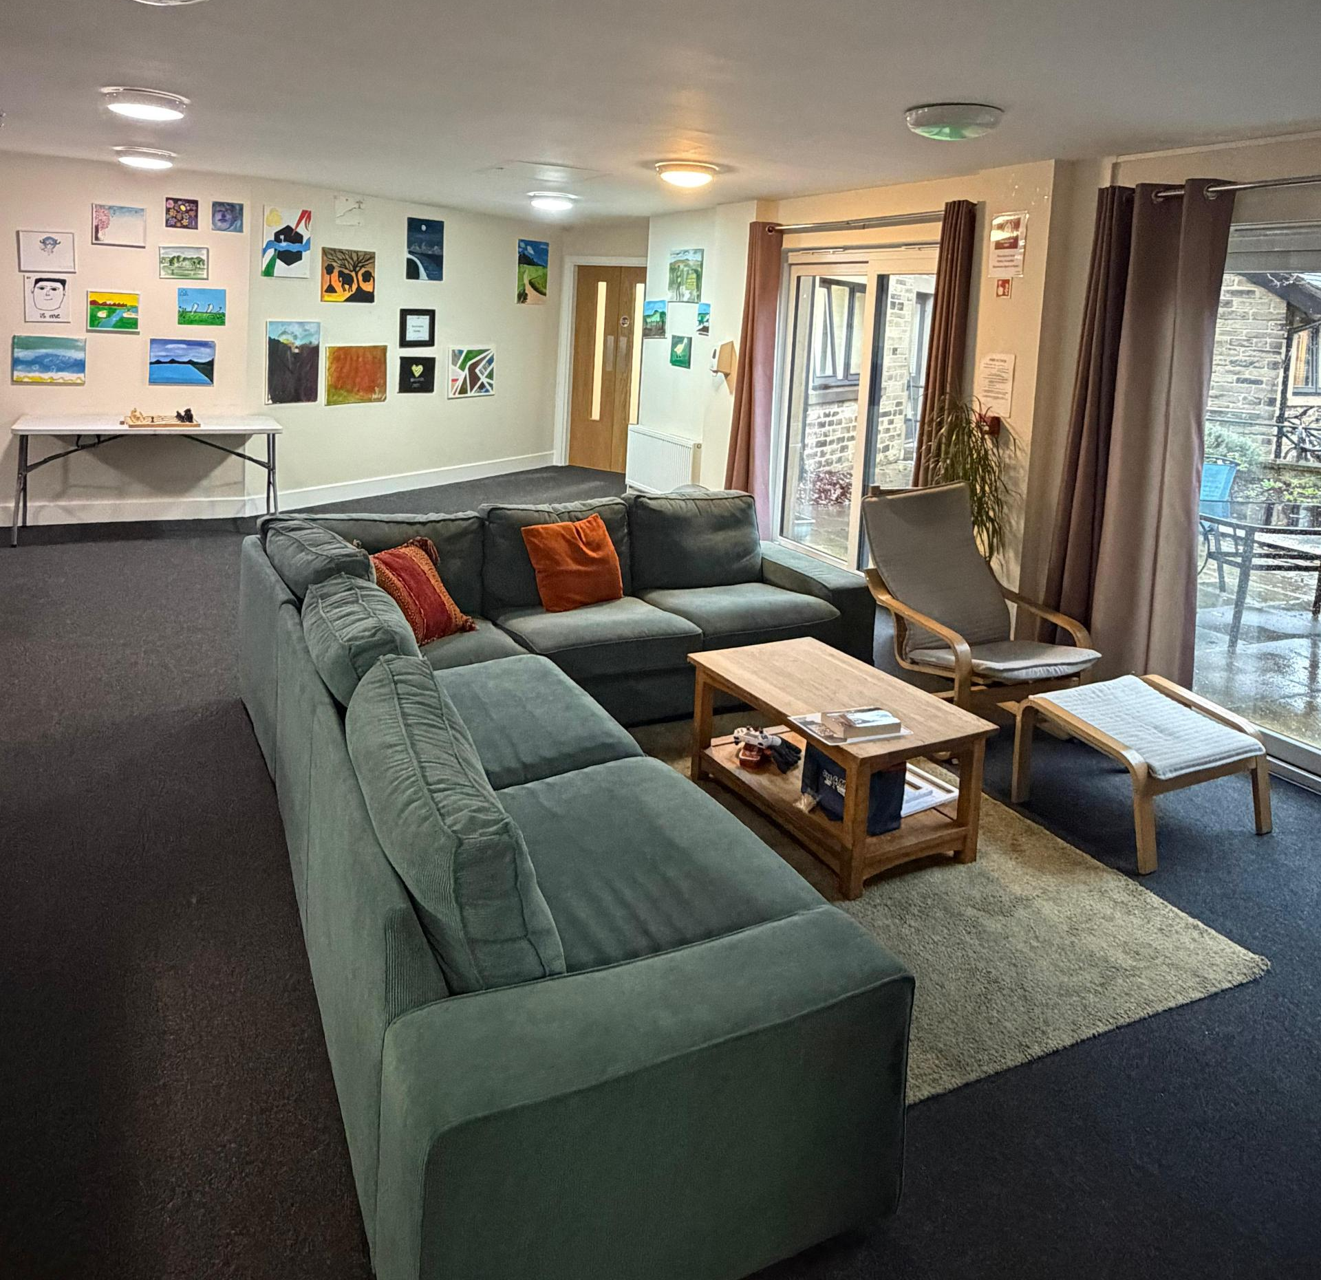
Entrance/Reception
Staff office
Communal room/ games area
Self-contained flats 1-16
Back office
Back-office kitchen
Courtyard garden
1 male toilet
1 female toilet
3 storage rooms

Outdoor and Community Facilities
The property features a courtyard with a paved seating area and a garden, offering a private and secluded space for young people to relax. This outdoor area is designed to provide a comfortable environment where individuals can unwind and enjoy time outside in a safe and tranquil setting.
In addition to the courtyard and garden, the property benefits from its proximity to Peel Park. Being next door to the park gives young people many opportunities to access extensive outside space, encouraging physical activity and recreation in a natural environment.
The location of Bolton and Undercliffe ensures easy access to the centre of Bradford, whether travelling by bus or on foot. Its central position enables convenient access to public transport, educational institutions, community services, healthcare providers, and other essential local amenities, supporting the needs and wellbeing of the young people living at the property.
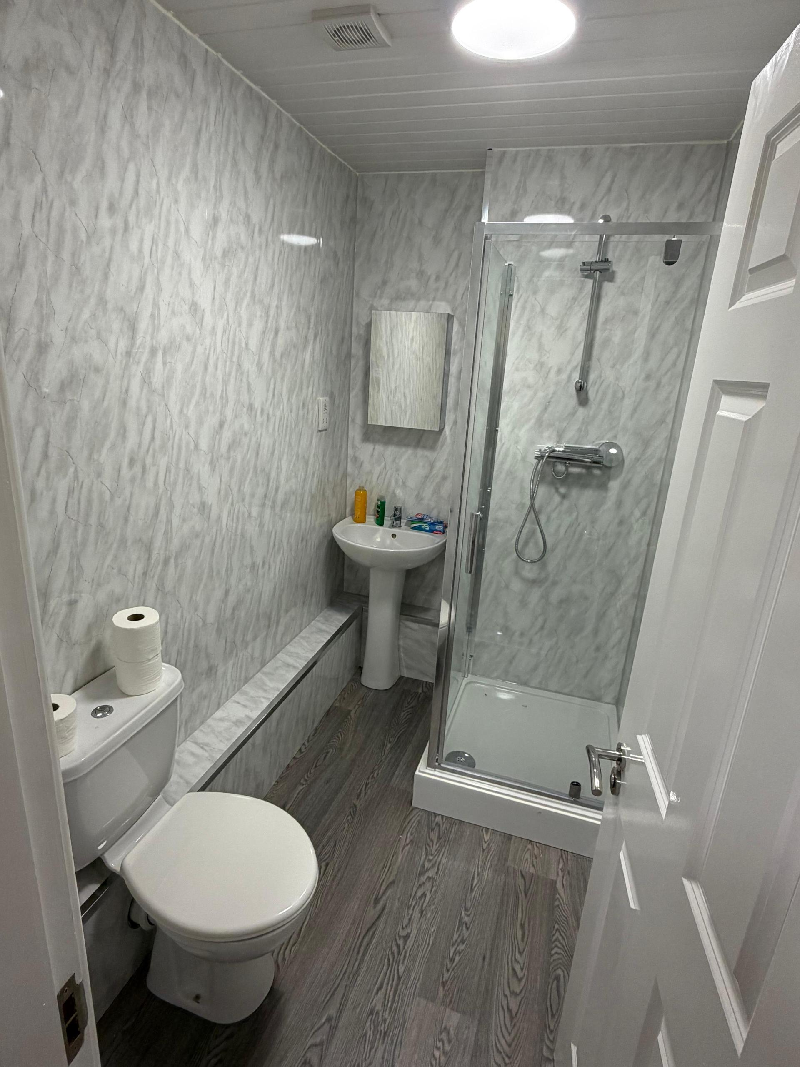
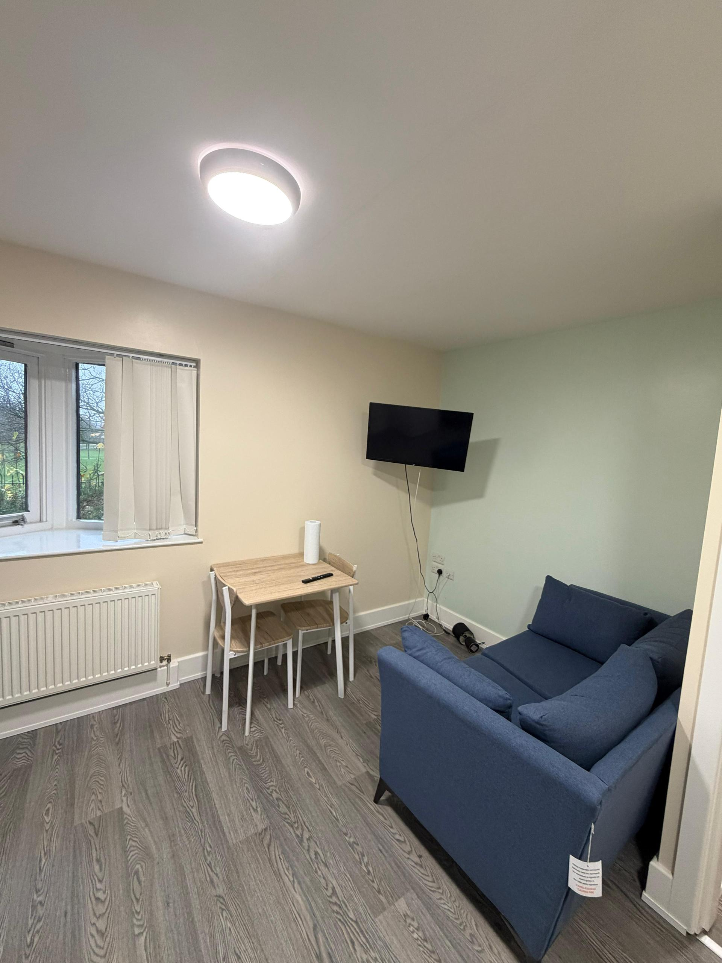
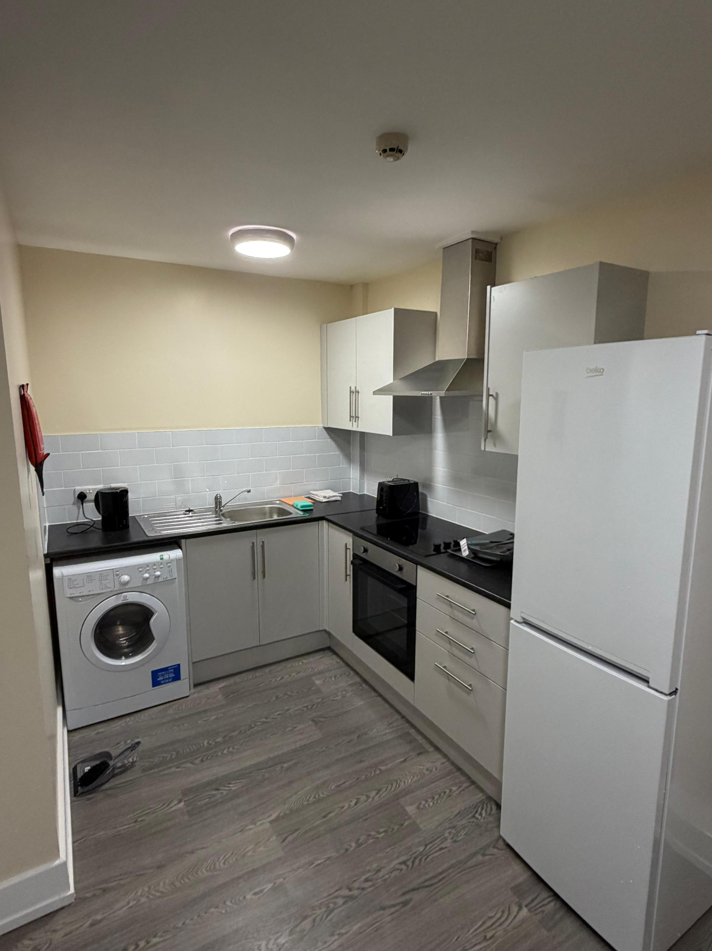

Accommodation Standards

General Standards
All our homes fully comply with the requirements set out in the Housing Act 2004 and meet the Decent Homes Standard. This ensures that each property provides a safe, secure, and well-maintained environment, conducive to the wellbeing of young people living there and suitable for staff to work from.

Servicing, Safety, and Maintenance
We are committed to maintaining high safety standards by ensuring all necessary servicing is consistently conducted. This includes regular gas safety checks, upkeep and testing of fire safety equipment, and the completion of a five-yearly Electrical Installation Condition Report. Any electrical items provided for the use of young people are subject to periodic Electrical Equipment Testing to guarantee their safe operation.
In addition to routine servicing, we conduct quarterly property checks of communal areas and six-monthly inspections of personal spaces. These checks are designed to assess and uphold the maintenance and safety of both the home and its grounds. Young people are actively encouraged to participate in these inspections as part of their independent living learning, fostering a sense of responsibility and involvement in their living environment.

Maintenance and Repairs
Our in-house maintenance team, supported by a network of approved contractors, undertakes all necessary repairs and maintenance within clearly defined timescales. This ensures the building stays in good repair and continues to meet the individual and collective needs of our young people by providing a comfortable and positive living environment.
Repairs are reported via our central management system, Homemaster, and are conducted in accordance with our Maintenance and Repairs Policy. Information on how to report repairs, as well as the relevant timescales, is included in the Young Persons Guide and is explained to each young person during their time in the home.

Insurance and Safety Measures
Our home is covered by adequate insurance that protects staff, young people, and members of the public. A certificate confirming this coverage is provided annually to the Local Authority.
To maintain a high standard of safety, several robust measures are in place, including:
- A Fire Prevention Logbook to record all weekly, monthly, quarterly, and six-monthly or annual fire safety checks and tests conducted at the home.
- A water temperature register for carrying out weekly and monthly checks.
- Various health and safety risk assessments to proactively manage and mitigate potential risks.

The Address of the Registered Provider

Horton Housing Association
Chartford House
54 Little Horton Lane
Bradford
BD5 0BS

Our Organisational Structure

Staff Training, Development, and Support
At Horton Housing, we recognise that our employees are the most important asset in delivering high quality care and support. In addition to mandatory training, we are dedicated to supporting the continual professional development of all staff members. Our aim is to foster a culture where workplace activities are valued for their learning potential, encouraging every employee to take full advantage of available training opportunities.

Learning and Development
The learning and development team plays a vital role in ensuring that all staff receive the support and training they need to effectively manage their workload. Through regular supervision sessions and an ‘open door’ policy, we provide regular updates and training to all staff, supporting the successful delivery of our services.

Recruitment and Induction
All staff are recruited in line with a safer recruitment framework and must hold a current enhanced DBS certificate. We have a workforce plan in place that outlines clear expectations about employment and recruitment for our group living services. The experience and qualifications of staff working within the home are carefully documented, with an accompanying plan for any further training or refresher sessions as needed. A comprehensive induction and supervision programme ensures that all colleagues fully understand their roles and responsibilities, particularly in relation to the support and protection of young people.

Probation and Supervision
New colleagues undergo a probationary period of six months, providing them with time to settle into their roles. Our documented induction process includes agreed timescales for completing induction, the probationary period, and all core training. Each colleague receives one-to-one supervision at least every eight weeks, with more frequent sessions provided if required.

Progress, Performance and Development
We follow a performance cycle that includes:
- Annual appraisal the focuses on talent management and career development
- Performance management, where colleagues need additional support to achieve expectations.
- Wellbeing/check-in meetings can be completed as and when needed.
- Monthly workload discussions to support scheme/service delivery.

Team Meetings
Weekly team meetings are held with the RSM, Managers and Team Leaders. Monthly team meetings take place at the home, with comprehensive notes taken and shared among all colleagues. The timing and days of meetings are varied to provide everyone with the opportunity to attend.

Qualifications
All colleagues are required to either hold or be working towards an NVQ Level 3 in Children and Young People, or an equivalent qualification.


Children’s Rights, Service Delivery, Support, and Planning
Referrals for placements will only be accepted through the Placement Coordination Team, or via the Emergency Duty Team (EDT) if the referral occurs outside of normal working hours. The responsibility for ensuring that placements are only accepted once the proper matching process has been completed lies with the GLS manager.
The matching process is comprehensive and includes careful consideration of the young person’s behaviours as detailed on the placement referral form, assessment of the young person’s specific support needs, and comparison with the profiles of young people already living at the placement, the Location Risk Assessment and consideration of Annexe A. This ensures the most suitable and supportive environment for each individual.
Our team is committed to making certain that every possible step is taken to prevent discrimination against young people. At Horton Housing, there is a strong focus on promoting everyone’s identity and enhancing everyone’s cultural awareness. Young people are encouraged to remain open-minded about different values and cultures, whilst always maintaining respect for others’ differences.
For those who wish to practise their religion, we provide every possible opportunity and support to facilitate this. Young people from diverse cultural backgrounds are positively encouraged to keep their own identities, and attention is given to their clothing, health care, and dietary requirements to ensure their needs are met.
Support is also available for young people with linguistic needs, including access to interpreters where necessary. All staff members are trained in Equality, Diversity, and Inclusion (EDI), as well as the protected characteristics outlined in the Equality Act 2010.
Prior to admitting any young person into the home, a detailed and careful consideration process is undertaken. We recognise that disadvantaged children, including many with protected characteristics, are overrepresented in supported accommodation. Therefore, it is our duty to ensure that right support is in place to meet these needs.
The GLS manager is responsible for assessing all information provided, evaluating any potential risks or additional needs, and making the necessary arrangements before a young person comes to live in our accommodation. This includes conducting risk assessments, organising small adaptations to bedrooms if needed, and considering the physical aspects of the home to ensure a safe and supportive environment.


Entitlements of Young People in Our Service
Every young person joining our service receives a Young Person’s Guide. This guide provides a thorough overview of what to expect from our staff and the accommodation, ensuring clarity before moving in. Where circumstances allow, we actively encourage young people to visit the home prior to their move-in date. We recognise, however, that this may not always be possible, especially in the event of emergency admissions.

Legal Rights and Supporting Legislation
The rights of young people in our care are underpinned by legislation, including the Children (Leaving Care) Act 2000 and the Children and Young Persons Act 2008. Since April 2018, the Children and Social Work Act 2017 has extended support for care leavers, entitling most to help from Children’s Services up to the age of 25.

Categories of Support
There are four categories of leaving care status which determine the support a young person may receive:
- Eligible child: Aged 16–17 and still in care.
- Relevant child: Aged 16–17 and previously in care.
- Former relevant child: Aged 18–25 and previously an Eligible or Relevant Child.
- Qualifying care leaver: Aged 16–25, who was in care for less than 13 weeks after their 14th birthday.
Most young people placed with us will fall into one of these groups, depending on their personal circumstances. Those who are eligible children remain technically in care and join our service as part of their transition to adulthood. For those in other categories, we ensure their rights are upheld and that they receive support according to their entitlements.

Entitlements for Eligible Children
Children’s Services must:
- Listen to the young person’s wishes and feelings.
- Appoint a Personal Adviser (PA).
- Assess needs.
- Prepare a Care Plan and a Pathway Plan.
- Review Care and Pathway Plans.
- Pay for accommodation and subsistence.
- Visit regularly.
- Provide access to an independent advocate.

Support for Other Categories
If a young person is not an Eligible Child, their rights and entitlements are clearly outlined and agreed upon at the planning meeting for their placement. This ensures each young person understands their entitlements and knows who is responsible for providing them.

Pathway Plan
After their 16th birthday, Children’s Services must assess the young person’s needs within three months. The young person will collaborate with Children’s Services to develop a Pathway Plan for their future. This plan details the support available, including accommodation, financial help, health and wellbeing, contact with family and friends, and arrangements for safety.

Reviews
Pathway Plans are reviewed at least every six months, and again before any significant change affecting the young person’s future. All reviews are chaired by the Independent Reviewing Officer (IRO).

Visits
Children’s Services are responsible for maintaining contact and ensuring the young person’s well-being. They are required to visit:
- Within the first week of any new placement.
- At least every six weeks thereafter.
- After the first year, and, if the placement continues until the young person is 18, at least every three months.

Financial Support
As a looked-after child, the young person continues to receive financial support from Children’s Services. The amount is agreed before placement and supports practical needs such as food, clothing, and transport, helping the young person to develop independence. Additional grants and funding for further education may also be available, with support workers helping to access these resources. During the transition to adulthood, Children’s Services must maintain support through their Local Offer, clearly outlining available help. We ensure all rights and entitlements are understood and upheld during any transition from Supported Accommodation to independent living.

Personal Adviser for Care Leavers
When a young person is no longer ‘looked after’, the local authority is legally required to appoint a Personal Adviser (PA). The PA advocates for the young person, provides advice and support, participates in the assessment and review of Pathway Plans, and monitors the young person’s progress and well-being.

Homeless Young People
Young people placed with us due to homelessness and assessed by Children’s Services as children in need are generally granted looked-after status. This entitles them to safety and support in education, health, financial matters, and maintaining family contact, where desired. Key workers help all young people access their full rights and entitlements.

Support for Unaccompanied Asylum-Seeking Children (UASC)
Unaccompanied Asylum-Seeking Children require additional support because of the complexities of asylum and immigration legislation, and because their care needs may change over time. Support focuses on short-term, achievable goals while their entitlement to remain in the United Kingdom is determined.
Planning for UASC is tailored to their unique circumstances and may include:
- A transitional plan during the period of uncertainty while in the United Kingdom without permanent immigration status
- A longer-term plan for remaining in the United Kingdom, if granted long-term permission such as Refugee Status
- Planning for a return to their country of origin, either voluntarily or if required, during or after the immigration process

Advocacy and Involvement in Decision-Making
Young people have the right to be involved in any decisions that affect them and should participate in all aspects of their placement and care plans. Children’s Services are responsible for supporting this participation by providing access to an advocate. Support is available to help young people obtain an advocate if they do not already have one, particularly to ensure support during any complaints process. Should a young person wish for an advocate to assist or speak on their behalf, arrangements can be made to facilitate this.


Achieving Positive Outcomes
Each young person will have a support plan designed to be person-centred and trauma-informed, ensuring all aspects focus on the individual needs of that young person. The plan will address several key areas essential for positive outcomes:

Health and Wellbeing
Maintaining the physical and mental health of every young person is a priority. We actively promote healthy lifestyles through practical activities such as cook and eat sessions, guidance during shopping, opportunities for exercise, and relaxation techniques. All young people are registered with a local GP and receive support to register with a dentist, optician, and sexual health clinic when necessary. Attendance at Looked After Children (LAC) health assessments, organised by their social worker, is also facilitated where required.
Young people receive information on maintaining a healthy lifestyle, encompassing both emotional and physical health. They are encouraged to attend appointments and obtain treatment as needed. Health education is provided on topics including smoking, sexual health, birth control, alcohol, and substance misuse—this may be delivered through leaflets, one-to-one support sessions, or by accessing external providers. We also support young people to attend their chosen place of worship and acknowledge any specific dietary requirements.

Education
All young people are supported in attending a school or college that is appropriate for their age. To aid their studies, each young person is provided with a desk in their room and access to Wi-Fi. Weekly support sessions with their designated support worker offer an opportunity to check in with the young person, discuss any concerns, celebrate achievements, address exam planning, bullying, and review school reports. Support workers collaborate closely with the young person and the Local Authority to review and implement any relevant aspects of their Education, Health and Care Plan (EHCP).

Staying Safe
Colleagues receive training to understand child exploitation, recognise warning signs, and escalate concerns to appropriate teams, including Social Workers, Emergency Duty Teams (EDT) when necessary, and families where appropriate. Support sessions cover important topics such as online safety, gangs, grooming, and radicalisation. Preventative measures are put in place, and young people receive information and guidance to help them stay safe at home, in the community, and as they move towards independent living.

Budgeting and Personal Finances
Young people are helped in developing budgeting plans and accessing any financial resources to which they are entitled, whether through benefits or their leaving care status. Support is provided to open bank accounts and ensure that each young person can access all the financial support available to them. Guidance on shopping—including creating basic shopping lists and going with young people to the supermarket if required—is also offered.

Maintaining a Home
Support is given to develop essential life skills, such as washing and keeping rooms clean. One-to-one sessions focus on the skills needed to keep a tenancy and the importance of adhering to these to avoid tenancy breakdowns. Colleagues discuss the significance of being a good neighbour and the adverse effects of anti-social behaviour. Each young person is shown how to respond in emergencies and how to report repairs.

Cooking Skills
Regular cook and eat sessions are organised, either individually or in groups, tailored to the needs of the young people being supported at any given time.

Independent Tenancy Options and Tenancy Readiness
Young people are supported to sign up for Bradford Homes, guided through the process of bidding for properties, and helped with viewing properties when needed.

Monitoring Progress
Progress is tracked using an Independence Tracker, which is completed monthly in collaboration with the young person and shared with their social worker or personal advisor.


Education, training or employment support
Each young person will be supported to access employment, training or education based on their own needs and wishes. We will ensure that they are encouraged and recognised for their achievements and also encourage them to take part in social, cultural and leisure activities.
We encourage the young person to develop positive routines to enable them to access education, employment or training and will support them to apply for bus passes and anything they may be entitled to which supports them.
Support plans are developed and appropriate to the young person’s needs, promote and support their independence and will clearly identify what we will do to support that person’s needs. The initial support plan is created from the initial referral information in consultation with the young person’s social worker/Personal Assistant, agreed during a planning meeting in the first 72 hours of the young person’s placement. The support plan must take into account information held on any other plans and the plan will be reviewed at regular care planning meetings or looked after review.
It is the role of the support worker and their manager to ensure that reviews are carried out in line with the young person’s status and to support a young person to access advocacy support or to raise a complaint.
Young people are encouraged to ‘have their say’ in all aspects of the support and time with us at the home. Comment postcards are also available and all young people are made aware of how to make a complaint upon admission and also in the young person’s guide. We also encourage participation in our annual client survey.
A Young Persons Independence tracker is completed monthly and shared with their social worker or personal advisor. We encourage young people’s views especially around the new regulation and quality standards such as this.
The intended outcomes for our young people are:
- Health, wellbeing and self-care – personal health, mental health, sexual health, accessing health and leisure services and exercising support in clothing and personal items
- Employment education and training – support to access education and training, accessing and employment searching, working with Connexions and other external agencies
- Staying safe – understand the risk of harm for others, including child sexual exploitation, and criminal exploitation. How to develop positive relationships, how to stay safe online, support to access other support services
- Budgeting and personal finances
- Maintaining a home – cleaning, laundry and how to deal with unexpected events such as leaks, utility disruption
- Cooking skills – food shopping, preparing and cooking a meal, food safety and what is a balanced and healthy diet on a budget
- Independent tenancy options and tenancy ready
- Improved self-care skills (personal care, diet, health)
- Improved practical skills, confidence and ability to live independently (manage & maintain their tenancy, shopping, cooking, budgeting)
- Improved interpersonal skills (managing friendships, sexual relationships, formal encounters and family/school/work relationships)
- Improved engagement in education (attendance and progress, return to learn options and preparation for work)
- Improved ability to manage their physical and mental health issues (engagement with specialist support)


Protecting and Supporting Mental and Physical Well-being
We assist young people in registering with GPs, dentists, and any other health services necessary to support their physical and mental well-being. Collaboration with social workers ensures that individual health plan targets are achieved. Where needed, we accompany young people to appointments and help them to manage medication responsibly.
A medication storage policy is in place, detailing the support available for safe dispensing, storage, and record-keeping. Our overarching aim is to enable young people to manage their own health needs with increasing independence.


Anti-Discriminatory Practices
We are committed to ensuring that no young person or their family experiences discrimination, marginalisation, or bullying on the grounds of age, religion or belief, disability, ethnicity, cultural and linguistic background, sex, gender reassignment, sexual identity, marriage or civil partnership, pregnancy and maternity, mental health, or any other reason. Cultural, linguistic, and religious needs are addressed during the placement process, and support is provided to help young people meet these needs.
Our organisation maintains a flexible approach, recognising that young people differ in understanding, development, and support needs, and that a tailored approach is essential to their safety and well-being.


Meeting Individual Cultural, Linguistic and Religious Needs
We ensure that young people can express individuality and exercise choice in their daily living arrangements, including decorating their rooms, selecting their clothing, and choosing activities that reflect their needs and interests.
Young people are supported in having full autonomy over their use of technology, with guidance from staff to ensure online safety. Attendance at places of worship is encouraged, and support is offered to maintain cultural identity, including observing a range of religious festivals where possible. We also foster confidence in self-identity across culture, language, religion, and LGBT+ identities.


How to complain and access our complaints policy
Young people are encouraged to voice any concerns or dissatisfaction regarding the service, home, practices, or staff. They may raise issues with anyone within the home, the organisation, or their social worker, and all concerns will be handled with seriousness, addressed appropriately, and resolved. Access to an advocate is available for those who wish to receive support in making a complaint.
Complaints can be given in person or in writing, through our website, text message, social media platforms, email, or letter. Prominent displays throughout the home encourage feedback and complaints. Regular feedback is actively looked for from young people about the service and support provided, and they are continually encouraged to express any concerns affecting themselves or others.
Social workers and other stakeholders also have channels to send complaints, either directly to staff members, the Registered Service Manager, or any Horton Housing employee. The complaints process includes notifying relevant authorities when necessary. Each Group Living Services Manager keeps records of complaints and their outcomes, which can be made available to Ofsted inspectors upon request. Our responsibility is to ensure no young person faces reprisals for making a complaint and that comprehensive support is provided throughout the process.
Horton’s Complaints Policy and Procedure adheres to the Housing Ombudsman Code of Practice, ensuring effective and fair responses to all complaints. The policy is readily accessible via our website or from any member of staff and is summarised within the Young Person’s Guide, discussed during their time with us.
Submitting a complaint does not result in negative consequences for the young person. This right is fundamental, and all feedback is respected and valued. Should a young person remain dissatisfied with how their complaint is managed or have additional concerns, they are encouraged to contact their social worker or any named contacts provided at the end of this guide. Our goal is to address concerns and provide appropriate support.
We have a separate Anti-Social Behaviour Policy for anyone to report complaints about the behaviour of people living in Horton properties.


Child Protection Policies

Safeguarding Culture and Staff Responsibilities
As an organisation, we maintain a robust safeguarding culture within our homes. Our colleagues are committed to doing everything possible to ensure that young people both feel and are safe. Staff members support young people in developing an awareness of their own safety and in managing it wherever possible, both inside and outside the setting.

Skills for Safeguarding
Safeguarding skills include the ability to identify signs that young people may be at risk, and to support them in accessing the help necessary to remain safe and reduce potential risks. We encourage young people to voice their perspectives regarding their sense of safety within and outside the setting.

Support Planning and Assessment
Each young person is provided with a support plan, developed based on their initial strengths assessment, direct conversations with them, and relevant information from their social worker, parents, or any other individuals involved in their care and support.

Assessment, Training, and Policy Overview
We conduct an annual locality assessment and maintain thorough records of staff training and supervision. A policy is in place for the notification of serious events to Ofsted and Bradford Local Authority. Our child protection policies underpin our strong safeguarding culture within the home and include the following:
- Safeguarding policy
- Missing child policy
- Behaviour management policy
- Location assessment
We are committed to ensuring that staff continually develop and refresh their safeguarding skills. All training is recorded in the workforce plan.

Whistle-Blowing and Reporting Procedures
Our policies for the protection of young people include clear information on whistle-blowing. Procedures are outlined for staff to report any concerns about a young person being at risk of or already experiencing significant harm to the appropriate authority. The policy reflects the principles set out in the ‘Freedom to Speak Up’ report by the Francis review.

Building Relationships and External Links
Staff work to establish positive relationships with young people and foster a culture of openness and trust, encouraging them to disclose any concerns or worries about their safety or well-being. Additionally, staff build useful links with external agencies that can provide further support and assistance to young people.

Information and Advocacy
Details on how young people can contact their placing or accommodating authority to request a review of their care or pathway plan, should they have concerns about their safety or welfare, are included in the young person’s guide. Young people are also supported to understand how to contact an independent advocate, Independent Reviewing Officers (IROs), their Personal Advisor, Ofsted inspectors, or other relevant individuals if they are worried about their safety.

Information Sharing and Legal Compliance
If there are concerns about a child's safety, information will be shared promptly and effectively to ensure that actions taken are in the child's best interests. The GDPR and Data Protection Act 2018 require organisations and individuals to process personal information fairly and lawfully, but do not prevent the sharing of information where withholding it would compromise a child’s safety or well-being.
All information sharing is in line with the fundamental principles outlined in ‘Working Together to Safeguard Children’, which clarifies the responsibilities and actions required if a child is being abused or abuse is suspected.

Promoting Positive Relationships and Risk Awareness
Young people are encouraged to form positive relationships both inside and outside the setting, including with professionals delivering floating support. However, staff remain vigilant to the possibility that some relationships may pose a risk to young people, whether these are with other young people in the setting, staff, family members, friends, or others outside the home. Where concerns arise, staff will take the appropriate steps to safeguard the young person involved.
Staff act as role models and help young people to understand the qualities of healthy, nurturing relationships. They are equipped to recognise the signs of exploitative or harmful relationships and to provide guidance and advice to young people on keeping themselves safe.

Supervision and Safeguarding Practice
Regular supervision of staff ensures that all adults working in the setting are fully engaged with the safeguarding culture of the service and understand their responsibilities should they observe any misuse or abuse of position by colleagues that could compromise the safety of a young person.

Understanding and Reporting Abuse
Staff support young people in understanding what constitutes abuse and provide them with information about how to report abuse or raise any concerns. Young people are given access to confidential and relevant resources, such as websites or helplines like Childline, to seek advice and support.
Youth voices are heard, and young people can report allegations without delay. Staff are required to report any allegations or disclosures of abuse immediately to the Registered Service Manager. All allegations of harm or abuse are handled in accordance with the provider’s child protection policy.
The Local Authority Designated Officer (LADO) is informed within one working day of any allegations made against staff members.

The Statement of Purpose: Section 2
All staff working at our GLS will be made aware of the contents of the Statement or Purpose and a copy will be made easily accessible.
In addition, we will ensure the Statement of Purpose is provided and easily accessible to:
- Any person who works in the home
- Any young person who lives in the home
- Any parent of any young person who lives in the home.
- Any Young person who may be considering moving into the home
- Any placing authority who may be considering the home for a young person.

The Statement of Purpose: Section 3
The Statement of Purpose (Regulation 9) is recognised as an important working document, kept under constant review by the Registered Service Manager. Reviews will always take into consideration any feedback or complaints from the young people or any other stakeholders so that any changes made have a positive impact on those affected by the change.
Any change to the Statement of Purpose will be communicated to Ofsted by the Registered Manager within 28 days of any changes.

