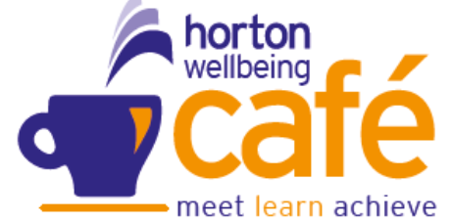
Wellbeing Café
November 2025



SELBY St Richards Centre, 36 Barwic Parade – Thursday 10am – 12pm (weekly)
EGGBOROUGH Methodist Church Wednesday 10am – 12pm (weekly)
SHERBURN Harold Mills House, Thursday 1pm – 3pm (Weekly)
TADCASTER Calcaria House, Windmill Rise Tuesday 10 – 12noon (Weekly)
 Hot Women – Menopause run by Jackie Butterworth @ Community House Selby –10am to 12pm
LIVING WELL – SMOKE FREE SSESSION with Fiona Robson – Stop Smoking Support @Selby – 20th November
ST LEONRDS HOSPICE VISIT with Lucy and Heather @ Selby and Sherburn group – 27th November
Sunday | Monday | Tuesday | Wednesday | Thursday | Friday | Saturday
 |  |  |  |  |  | 1
2 | 3 | 4  Tadcaster  Coffee, Talk, Mindful Activities | 5  Eggborough  Coffee, Talk & Mindful Activities | 6  Selby  Closed  Sherburn  Coffee, Talk & Mindful Activities | 7 | 8
9 | 10 | 11  Tadcaster  Coffee, Talk, Mindful Activities | 12  Eggborough  Coffee, Talk & Mindful Activities | 13  Selby  Closed  Sherburn  Coffee, Talk & Mindful Activities | 14 | 15
16 | 17 | 18  Tadcaster  Coffee, Talk, Mindful Activities | 19  Eggborough  Coffee, Talk & Mindful Activities | 20  Selby- Living well smoking free  Sherburn  Coffee, Talk & Mindful Activities | 21 | 22    10am to 12pm  @ Community House
23 | 24 | 25  Tadcaster  Coffee, Talk, Mindful Activities | 26  Eggborough  Coffee, Talk & Mindful Activities | 27  Selby  St Leonards  Sherburn –  St Leonards  Coffee, Talk & Mindful Activities | 28 | 29

